Paddit, Keith Martin C. DS163

Basic Linux Command Line Prompts

1. Here, the ls command is used to list the contents of the current directory.

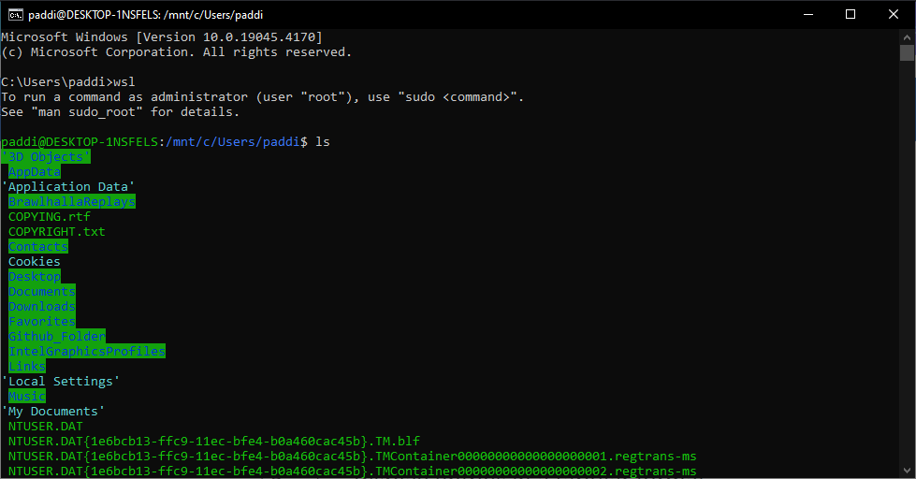

1. This shows the use of the cd command to change directories.

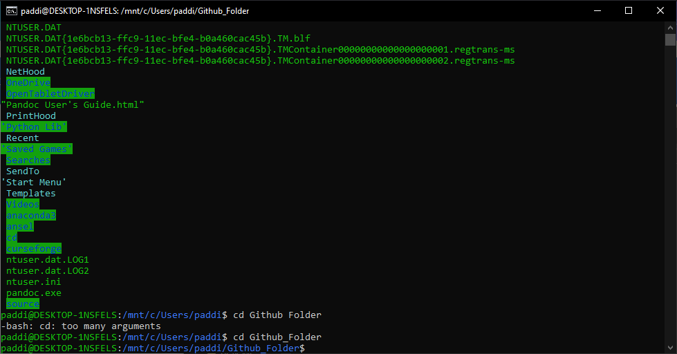

1. The mkdir command is used to create a new directory named test. The screenshot shows that after creation, the ls command is used to confirm the directory's existence.



1. This demonstrates the use of rm -r to remove a directory named test recursively, which includes all its contents. Afterward, ls confirms the directory has been deleted.



1. The mv command is used to move a directory called test to the parent directory, and then cd .. is used to navigate to that parent directory.

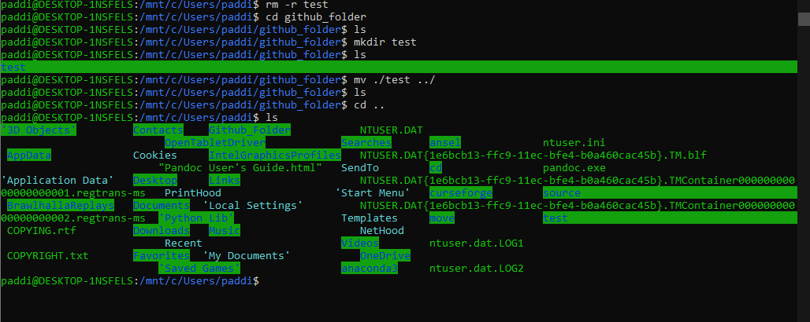

1. The pwd command displays the present working directory of the user. It confirms that the user is in the "paddi" directory within "Users".



1. This displays the use of the cp -r command to copy the directory called ‘test’ from the current directory to another directory called ‘github_folder’

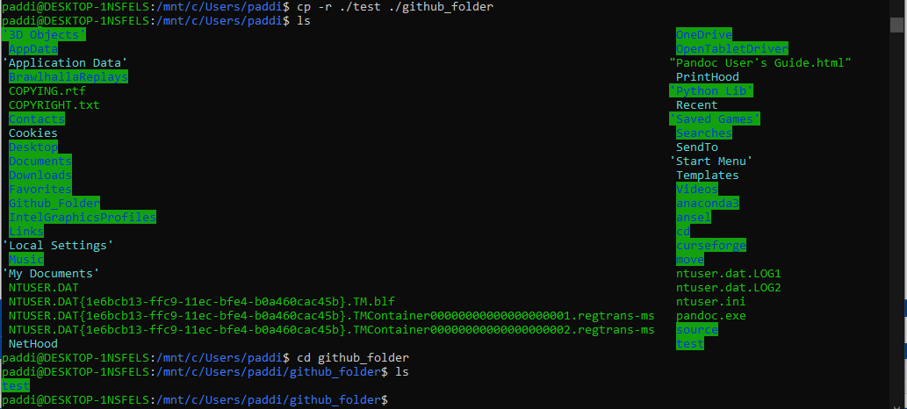

1. This displays the use of tar in zipping the PNG files in the directory of the ‘github_folder’

